Upper Hutt 41 Club
41 Club New Zealand – 2023 Reunion Registration Form
Feilding Thursday 30th March to Sunday 2nd April
Personal Details
Surname ____________________________ 41 Club ________________________________
Member ____________________________ Known as_______________________________
Wife/Partner _________________________Known as ______________________________
Address ____________________________________________________________________
___________________________________________________________________________
Phone Home ( )_____________________ Mobile_________________________________
Email ________________________________________
Registration
$150 per person. Please pay by direct credit to Upper Hutt 41 06-0996-0685563-00
Dietary requirements
If you have any special dietary requirements please specify ___________________________
___________________________________________________________________________
Health/ Mobility
As there will be some walking, particularly on the Saturday, if you have any health/mobility issues please specify
Accommodation is held at South St West Motel. 063231811
Contact Motel and mention 41 Club
An option exists for motor homes / caravans to be parked adjacent to motel. There is a unit that can be shared by caravan / motor home users for showers etc. If interested contact Peter Richardson
Transport
If you require transport from Palmerston North airport please advise flight details_________________

Contacts Mike Hoggard mataiawa@inspire.net.nz
Bruce Bold Reunion Chair,
Email registration to Peter Richardson peterrichardson1135@gmail.com

Welcome to Feilding, the centre of the mighty Manawatu. It is one of NZ most important Agricultural Hubs.
We have got on hold accommodation at the South St West Motel. http://www.southstreetwest.co.nz/ . This motel sits at the entrance to the Mansfield complex and only 600 metres from centre of town. There are No Homeless
We have a comprehensive programme and are covering several different interests.
For History we will be going to the stagecoach museum which covers early pioneering, as well as a massive display of vintage machinery http://coachhousemuseum.nz/
The heart of Feilding, the saleyards in the middle of the town. Feilding residents are proud to say “the smell of money”. The saleyards run 3 days a week with the largest being Friday.
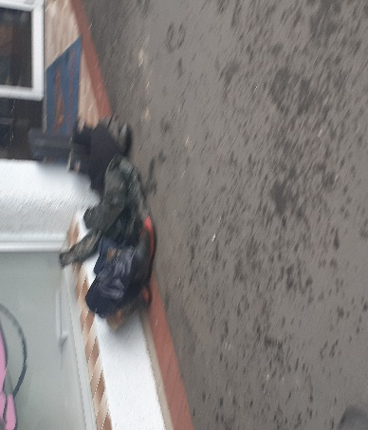
And no, you don’t need to bring any gumboots. Saleyards and farm do not require them.
We are going to look at the future with a visit to the new highway that is to replace the Manawatu Gorge Rd.
Back to past with a Farm BBQ.
Art, we couldn’t believe our luck in that the Kimbolton Rural sculpture day is on as well this weekend. https://www.ruralart.nz/
A dinner at the Feilding Gentleman’s club, one of the two remaining locker clubs in NZ.
After our farewell breakfast on Sunday morning, there is the opportunity for those who want to drive the Mansfield racetrack behind a safety car. Please contact Peter Richardson if interested. A charge to the racing club of $10 per car, your responsibility.
We look forward to meeting you all again

